Technical Note

Response to Inspector’s Initial Findings for the Tunbridge Wells Borough Local Plan

Tudeley Garden Village

|  |  |
| --- | --- |
| Project Number: | 22316 |
| Doc Number: | TN01 |
| Prepared for: | The Hadlow Estate |
|  | 25 April 2023 |

|  |  |  |  |  |  |  |
| --- | --- | --- | --- | --- | --- | --- |
| Rev | Issue Purpose | Author | Checked | Reviewed | Approved | Date |
| 01 | Draft | MH/HA | AN | MH/HA | AN | 21/04/2023 |
| 02 | Final | MH/HA | AN | MH/HA | AN | 25/04/2023 |

# Introduction

* + 1. Markides Associates has been commissioned by The Hadlow Estate to review and respond to the initial findings of the Inspector with respect to the proposals at Tudeley Garden Village (TGV), promoted through the emerging Tunbridge Wells Borough Local Plan.
    2. Following the Local Plan examination and associated hearings, the Inspector’s initial findings were published in November 2022. The initial findings, amongst other matters, discussed Policy STR/SS3, The Strategy for Tudeley Village, which seeks to develop a new settlement between Paddock Wood and Tonbridge.
    3. The Inspector offered several comments with respect to the proposed TGV allocation, raising concerns regarding the justification and effectiveness of the proposed allocation along with its impacts on the Green Belt. This Technical Note seeks to review and respond to the comments raised regarding the transport strategy and associated evidence base presented for the site. The comments raised by the Inspector with respect to the transport strategy focus on four key areas:-
* Bus Provision;
* Walking and Cycling Infrastructure;
* Trip Internalisation, Modal Shift and Severity of Traffic Impacts; and
* Five Oak Green Bypass.
  + 1. Each of these areas will be considered in turn within this technical response.

# Bus Provision

* + 1. The Inspector’s initial findings make a number of comments on the feasibility and effectiveness of the proposed bus improvements through the proposed TGV. The Inspector notes that without a new railway station, the site’s sustainable transport aspirations are reliant on buses alongside active travel.
    2. WSP’s previous work[1] on behalf of the TGV proposal identifies the enhancement of the existing bus route serving the B2017 corridor between the towns of Tonbridge and Paddock Wood. The Inspector correctly notes that the existing route 205 only runs hourly, Monday-Friday, between the hours of 07:35 and 18:02. Existing census data shared within the same report demonstrates that this level of service is only attributable to a 1% mode share for buses for travel to work.
    3. WSP therefore proposed that this service be increased to a 30-minute service initially, before then running every 15-minutes once TGV is sufficiently built out to make this a more frequent service. WSP also proposed an increase in operational hours, running from Monday-Saturday.
    4. The provision of such a service through the delivery of TGV is itself backed up by the Infrastructure Delivery Plan (IDP)[2], which identifies a “Direct and Rapid” service on route 205 as being a requirement of delivering the Local Plan.
    5. It should be noted that the use of a bus from TGV to Tonbridge Railway Station with a service of sufficient regularity, becomes a very attractive option. The current bus journey time using service 205 from Tudeley to Tonbridge railway station is estimated at just 15-minutes at 07:44 (including an assumed 4-minute walk at the TGV origin point and a 2-minute walk at the Tonbridge station end) using Google maps journey time planner. The 205 route already travels via Tudeley and the masterplan will be designed to ensure every resident of TGV is within a 400m walk (5 minutes) of a bus stop utilised by this service, as per the Chartered Institute of Logistics and Transport (CIHT) best practice[3]. Therefore, the use of the bus to access Tonbridge Station will be a very clear and attractive choice for those taking public transport.
    6. As well as the routing and frequency of any bus service, reliability and average journey times are key to encouraging modal shift towards buses. In this respect, a significant section of currently private road, owned by the promoter of TGV, is being offered to Kent County Council (KCC) as part of the TGV proposal as a dedicated bus and cycle route. The route along Tudeley Lane, as described in Section 2.3 of the WSP report, connects the bus service from the TGV site boundary with Tonbridge, avoiding the A26 and/or A21, providing significant journey time savings. This will deliver a significant enhancement to sustainability for the area generally.
    7. It is also expected that other bus journey time savings can be delivered on the section of the route through Tonbridge itself. The promoters of TGV will work with KCC and Tonbridge and Malling Borough Council (TMBC) to identify further opportunities to implement bus priority improvements, helping to further incentivise increased bus travel.
    8. A bus feasibility study prepared by KCC[4] identified a number of further opportunities along the Tonbridge to Paddocks Wood bus corridor that would improve journey times by approximately 17% and bus speeds from 20mph to potentially 24mph, both of which would improve reliability. This study has been prepared by KCC, working in partnership with TWBC, and demonstrates that the delivery of an enhanced bus service along this corridor is already being considered, possibly with the introduction of Bus Rapid Transit (BRT) style measures.
    9. The net effect of these frequency, routing and reliability improvements will be a bus service that provides a very attractive alternative to travelling by car. This level of service aligns with CIHT best practice, and therefore has the potential to increase the bus mode share to 9% or higher as seen in other areas of the country with comparable bus services[5].
    10. The fact that there is an existing bus service running between Paddock Wood, Tudeley and Tonbridge represents an excellent foundation of bus travel on which new development at Tudeley can build. The development at TGV will add a significant number of new passengers to local demand to ensure the viability of the increased service, and together with appropriate financial contributions should easily be able to justify the increases in bus frequency and service days, which would be included as a commitment for the development.
    11. The Inspector has asked for information about the feasibility of such a service in circumstances where discussions with KCC and bus operators have not progressed to a detailed stage. As with all any such service, the promoters of TGV recognise that further collaboration will be required in due course to deliver the enhanced bus service, but this is common for this stage of the planning process. WSP provided evidence that the proposed increase to service levels would be self-financing (i.e. commercially viable without contributions at the point of 2,000 dwellings), and that a financial contribution in the estimated order of £600,000-£900,000 is proposed to secure the service in the interim period. This assessment is a robust estimate that would be further detailed as part of any planning application submission and up to date contributions secured at that stage.
    12. Accordingly, the proposed improvements to the bus service are appropriate and are entirely deliverable through the planning process. The work to-date has demonstrated that a viable, frequent, direct and much more reliable bus service will successfully link the site with the two nearest urban centres, Tonbridge (and Tonbridge railway station) and Paddock Wood via TGV and deliver sustainability not simply for TGV but for this area generally.

# Walking and Cycling Infrastructure

* + 1. The allocation of TGV will be within an approximate 4km distance from Tonbridge town centre and Tonbridge railway station. This represents approximately a 45-minute walk or a 15-minute cycle ride.
    2. As noted in the Inspector’s findings, this distance is too far to walk in the majority of cases, and therefore the site will be reliant on cycling trips to meet any active travel aspirations for such trips to the town centre of Tonbridge. However, it is considered the site is well situated to achieve a significant number of cycling trips, given that the UK average cycling trip distance is 5.8km[6] as compared to the 4km distance of TGV from Tonbridge. Every resident of TGV would be within an easily cyclable distance of Tonbridge.
    3. The illustrative masterplan provides for the creation of a cycle route at and through the heart of the community. This can and would be LTN1/20 compliant, affording high quality, segregated infrastructure to encourage all levels of ability to cycle along this route. The design would locate the cycle route in areas that encourage natural surveillance from neighbouring properties. It would have appropriate street lighting (addressing the Inspector’s concerns about darker winter months), making the route safe and secure. The route would also be hard surfaced, enabling the ability to cycle all year round and outside of daylight hours. The reference to usage being affected by inclement weather is a point that would apply to any cycle provision in any part of the country but this is not a reason to treat the provision of such dedicated cycle routes within easy cyclable distance to be unsustainable.
    4. The delivery of this cycle route at the heart of the community within easy cyclable distance of the major town centres and railway stations fits with the policy ambition to significantly grow cycling mode share, as stated within Central Government’s ‘Decarbonising Transport’ and ‘Gear Change’ reports, as well as KCC’s ‘Local Transport Plan 4’.
    5. It is recognised that providing such good cycle infrastructure across the TGV development will not only provide a holistic network that enables cycling into Tonbridge, Five Oak Green or Paddock Wood, but will also be part of a wider co-ordinated set of proposals developed to ensure the cycle routes are secure, safe and direct across their whole lengths.
    6. The proposals have been co-ordinated with the developing Tunbridge Wells Borough Council (TWBC) ‘Local Cycling and Walking Infrastructure Plan’ (LCWIP)[7]. Figure 3.1 sets out the routes proposed for investment within TWBC, including route D which provides the important connection between Five Oak Green and Tonbridge via the TGV site.
    7. The proposed Route D provides an option for cyclists which is largely free from traffic, via the public right of way along Postern Lane and the riverside tow path.

Figure 3.1 Tunbridge Wells LCWIP: Cycle Routes

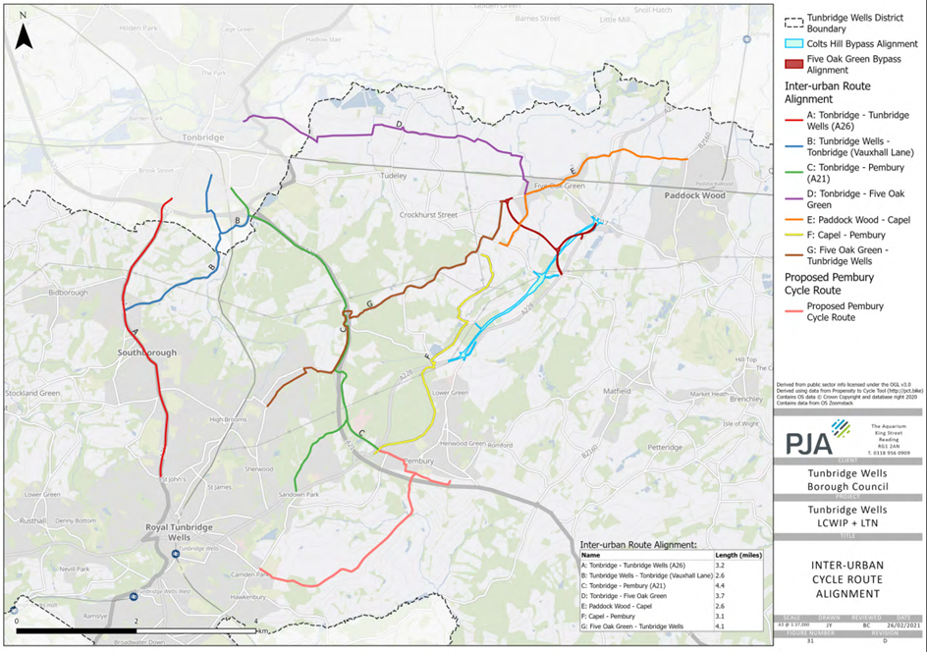

Source: PJA on behalf of Tunbridge Wells Borough Council

* + 1. Given Hadlow Estate own much of the land bordering the B2017 and A26, it is entirely feasible to provide further high-quality cycle facilities, that are designed to best practice standards, connecting with other parts of Tonbridge securely and safely.

### Cycling Connections with Tonbridge

* + 1. TMBC are yet to publish its LCWIP or adopted Active Travel strategy. However, the latest consultation proposals from March 2022[8] focus cycling improvements, with a number of suggested routes, as shown in Figure 3.2.
    2. This map demonstrates three proposed routes serving the town centre, from the western extents of the town, as shown in green (riverside route), light blue (industrial / retail route) and indigo (Vauxhall / school route).

Figure 3.2 Tonbridge and Malling Active Travel Strategy: Proposed Routes

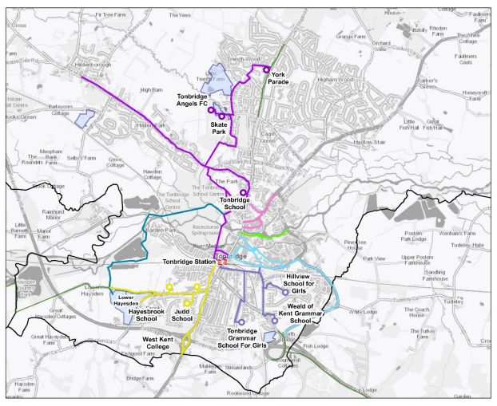

Source: Tonbridge and Malling Borough Council

* + 1. The green route connects with the proposed end point of route D from the TWBC LCWIP and provides the important continuation of the TGV cycle route into Tonbridge town centre. In addition, the indigo-coloured route connects with the Weald of Kent Grammar School, which is situated on Tudeley Lane and intersects with the proposed bus/cycle only route.
    2. Finally, there are multiple options for a further cycle route from TGV to connect directly with the light blue route along the A26, given the Hadlow Estates land holdings border the A26 and connect with the proposal.
    3. TGV is therefore not reliant on one route to enable the creation of excellent cycle connections with Tonbridge. There are a variety of options to provide routes that will cater for all abilities of cyclist, providing the ability to cycle in all weather, lighting conditions and time periods. These options, along with the bus service (dealt with above), will provide a genuine alternative to car travel and confirms the sustainable location of the proposed site.
    4. The developer will work closely with KCC and TMBC for the development of these proposals further ahead of future planning application submissions, to ensure that multiple high-quality routes are delivered in line with LTN 1/20.

### Potential for Cycling Mode Shift

* + 1. The potential modal shift that could be achieved from cycling through the provision of these cycling routes is significant. The Department for Transport’s ‘Propensity to Cycle Tool’, promoted by the department to develop their LCWIP strategies, shows the potential future mode share - see Figure 3.3 below**.**

Figure 3.3 Propensity to Cycle Tool: Existing and Future Scenario

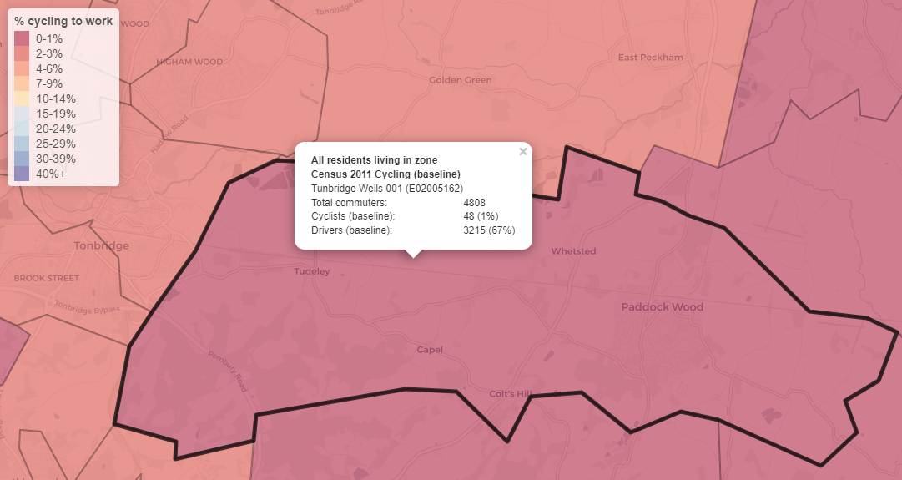

Source: Propensity to Cycle Tool

* + 1. This tool identifies that TGV has the potential to grow its cycling mode share from its current level of 1% up to a potential 19%, given wide adoption of e-bikes and assuming good cycle infrastructure is embedded as proposed. TGV will aspire to this target through the design of its masterplan in such a way that incentivises active travel over car use as well as contributing to improvements outside of its red line to enable the delivery of exemplary whole cycle routes, working with TMBC and TWBC closely.

# Trip Internalisation, Modal Shift and Severity of Traffic Impacts

### Internalisation Factors

* + 1. Within the Inspector’s initial findings, concern is raised regarding the level of trip internalisation and modal shift achievable at the site, based on current evidence and in turn, the implications of this for highway capacity within Tonbridge town centre. The Inspector’s initial findings state:-

*‘Given the existing constraints and congestion in Tonbridge town centre, the cumulative impacts of the scale and location of the development would be severe’.*

* + 1. As part of the Local Plan evidence base, detailed assessments from both Stantec[9] and WSP[10] have considered the potential effects of internalisation at TGV. Table 4.1 below summarises the two approaches and the associated internalisation factors derived based on journey purpose.

Table 4.1 Trip Internalisation Summary

|  |  |  |
| --- | --- | --- |
| Journey Purpose | Stantec | WSP |
| Employment / Commuting | 10% Internalisation | 20% Internalisation (equating to 3% of all trips) |
| Business | - | 100% Internalisation (to allow for home working, equating to 3% of all trips) |
| Education | **Primary School** – 80% Internalisation  **Secondary School** – 50% Internalisation | 90% Internalisation (equating to 6% of all trips)  **Education Escort\*** – 90% Internalisation (equating to 5% of all trips) |
| Retail | **Local Shops** – 75% Internalisation  **Supermarket** – 50% Internalisation | 50% Internalisation (equating to 9% of all trips) |
| Personal Business | **-** | 50% Internalisation (equating to 5% of all trips) |
| Other including just walking | **-** | 100% Internalisation (equating to 6% of all trips) |

*\* used when the traveller has no purpose of his or her own, other than to escort or accompany another person; for example, taking a child to school.*

* + 1. The total internalisation detailed by Stantec using their trip impact assessment[11], indicates that 56% of all person trips could be internalised within the AM peak with 41% internalisation estimated for the PM peak. For WSP, a total internalisation factor of 38% was identified.
    2. As to commuting and retail trips, a commercial and retail floorspace assessment has been completed by Marrons[12]. For the commercial aspects, the report assesses that *‘46% of retail expenditure will be retained within Tudeley Village’* based on the scale of the retail capacity proposed. This level of internal expenditure broadly aligns with the internalisation factors detailed by WSP and Stantec (for the supermarket), highlighting the capacity of the onsite retail facilities to capture demand from residents.
    3. For commuting, the Marrons report demonstrates that *‘the proposed commercial floorspace would broadly provide employment needs for 15% of residents’*. This is a robust assessment where this figure refers only to the dedicated, traditional B Class (now Class E) floorspace and town centre retail, and without including the effects of other on-site employers such as the educational facilities. This assessment lies between the internalisation factors for both Stantec and WSP, highlighting the appropriateness of the assessments made and clearly demonstrating the suitability of the land uses proposed to offer meaningful employment opportunities for future residents.
    4. Within the report, an initial assessment of the impacts of COVID-19 and home working are also outlined, with Marrons noting that the 2021 Census indicates 43% of Tunbridge Wells residents as working from home, compared to only 14% for the 2011 Census. It is appreciated that the 2021 Census was conducted during a period of COVID-19 restrictions, where the level of home working is likely to have been greater than current conditions.
    5. Recent evidence by the ONS notes that *‘among working adults who have worked in the last seven days, 16% reported working from home only and 28% reported both working from home and travelling to work over the period September 2022 to January 2023[13]’*. Due to the timings of the reports from both Stantec and WSP, a more limited consideration of the ongoing home working trends was considered, with no explicit account for home working provided by Stantec and only a small percentage (3% of trips) reflected within the WSP assessment.
    6. The Marrons report concludes that *‘it is therefore reasonable to assume that between 30% and 58% of Tudeley Village residents could potentially work locally – either at home or within the planned commercial floorspace’*. Given the levels of internalisation analysed above, these figures reflect a robust assessment of future travel at the site, and which would be expected to be increased based on home and hybrid working patterns for the future.
    7. The site proposes the development of a 3 Form Entry (FE) primary school and 6FE secondary school. KCC, as the Local Education Authority, assess need for education for new developments using Pupil Product Ratios (PPR). KCC assess Pupil Product on the assumption that new development comprise 90% houses and 10% flats, with the following PPRs:-
* **Primary Education** – Houses = 0.28 and Flats = 0.07; and
* **Secondary Education** – Houses = 0.20 and Flats = 0.05[14],[15].
  + 1. Based on the assumption of 210 pupils per FE, the primary school has a capacity of 630 pupils with the secondary accommodating 1,260 pupils. Taking the above PPRs and the development of 2,800 units, the following demand for education places is estimated:-

Table 4.2 Education Internalisation

|  |  |  |  |  |  |
| --- | --- | --- | --- | --- | --- |
| Education Type | Flats | Houses | Total | Onsite Provision | Internalisation |
| Primary | 20 | 706 | **725** | 630 | **87%** |
| Secondary | 14 | 504 | **518** | 1,260 | **100**% |

* + 1. The above indicates that the proposed 3FE primary school could accommodate 87% of the total demand generated by the site, with all secondary school demand being accommodated onsite. It is acknowledged that Kent operates a selective education system for secondary school places, which results in a proportion of secondary aged pupils being enrolled at selective grammar schools. Therefore, whilst the scale of the secondary school accommodates the total demand, it is acknowledged that an element of secondary school aged pupils will travel off site for grammar school enrolment, but this would be the case for any development anywhere in Kent in consequence of this policy.
    2. When comparing the assessment methodology outlined in Table 4.2 to the internalisation figures of both Stantec and WSP, it is maintained that the onsite educational facilities allow for internalisation to be capitalised at the site.
    3. No further internalisation was included by Stantec in their report, whereas some allowances were made for personal business movements and other internalised journeys which are likely in WSP’s assessment. Given the additional evidence now presented, it is clear that the information that has been submitted to date with respect to internalisation provides a robust and realistic basis for assessment of the effects of the mix of uses proposed in this location and it proves that the scale of internalisation assumed is not unreasonable or unrealistic.
    4. These assessments do not include localisation effects, whereby existing trips on the road network could be made shorter in the future, as a direct result of the new site’s facilities and employment opportunities. Therefore, arguably, the level of reduction of trips on the highway network has actually been underestimated, rather than overestimated in the assessments provided.

### Modal Shift Assumptions

* + 1. In conjunction with the internalisation factors, the potential for modal shift has also been assessed. SWECO, within their strategic modelling for the Local Plan, have assumed a 10% modal shift for the reduction in car driver movements.[16],[17] They consider this to be realistic based on analysis of case studies which has benchmarked this figure against other schemes as part of the Department for Transport’s (DfT’s) Sustainable Travel Towns analysis. Within their methodology, Stantec considered a 40% reduction in the car driver mode share to be reasonable[18]. WSP indicate a modal shift from 76% car driver to 50% car driver on completion of the proposals for the evidenced reasons they gave [19].
    2. The earlier sections of this response also refer to feasible and deliverable active transport improvements proposed as part of TGV. Given the conclusions reached with respect to these elements of the proposals, it is clear that modal shift can be achieved within TGV, with high frequency bus services and high quality walking and cycling facilities providing residents with genuine modal choice. Based on the evidence presented it is clear that the allocation at TGV does allow for viable modal shift to take place.
    3. Given that the DfT’s own scenario projections for cycling reveal a mode share of anything up to 19% for cyclists, and past precedent for bus enhancements of the kind proposed demonstrate a mode share of 9-15% is achievable, it is reasonable to assume the modal shift of 10% by SWECO in the strategic modelling is robust, and with the potential to go further.

### Traffic Impacts in Tonbridge

* + 1. It is important to note that the capacity of the junctions within Tonbridge assessed by SWECO in the Transport Assessment Addendum 2 document[20] sets out the detail of those assessments **without** taking into account the internalisation and localisation rates for either TGV and Paddock Wood or other reductions in trip rates due to changes in how people travel. The Transport Assessment Addendum 2 document was completed following discussions with KCC and National Highways (NH), who requested a sensitivity assessment of the Local Plan allocations using the TRICS database. The sensitivity assessment explicitly states that:-

*‘The trip rates also do not include adjustments for internalisation / localisation rates of the new Local Plan sites in Paddock Wood and Tudeley as well as the wider area around Paddock Wood in particular. Nor does it include reductions in trip rates due to change in how people travel[21].’*

* + 1. The proposed mitigation measures for the town centre junctions, as outlined by SWECO, focus on modal shift and traffic management in Tonbridge town centre, which are to be achieved through improvements to walking, cycling and bus services. Physical improvements to the A26 / Three Elm Lane junction have, however, been identified in the form of a signalised junction proposal. The resulting operations of the junctions identified are shown in Figure 4.1- and are the ‘worst performance’ estimates.

Figure 4.1 Tonbridge Town Centre – Local Plan Capacity Assessment[22]

Source: SWECO

* + 1. Using these to provide an average level of junction performance across the corridor, a comparison between the various scenarios is as shown below:-
* **Reference Case (RC)** = 91%;
* **Local Plan (LP)** = 95%;
* **Local Plan Highways (LPH)** = 93%; and
* **Mitigation Scenario (MS)** = 88%.
  + 1. Assuming no interventions are delivered (the difference between the RC and LP scenario) there would be a total change of only +4% with respect to the volume / capacity ratios of these junctions. On completion of wider mitigation measures, cumulatively, the junctions under assessment will in fact be improved, with a resulting lower volume / capacity figure than the RC (88% compared to 91%). The mitigation measures primarily stem from modal shift and traffic management schemes rather than internalisation and other reductions that are outlined above. Based on the above, and without the effects of internalisation considered, it is reasonable to state that the impacts cannot be considered as ‘severe’.
    2. When considering the test of severity in the Framework, several appeal decisions confirm that severity is a ‘high bar’ or ‘high threshold’ for intervention and that congestion and inconvenience alone are not sufficient to trigger the ‘severe’ test, which needs to be related to the consequences of congestion[23],[24]. Currently, the evidence base presents only the capacity assessment of these junctions, with no greater detail regarding the potential implications of the modelling. Without such analysis, it is not considered that the information presented is sufficient to conclude that the severity test has been met at these locations.
    3. Additionally, as already noted, the above results do not account for the levels of trip internalisation that form part of the Local Plan evidence base, which has been discussed above. In addition, that evidence base and associated modelling also assume the full development of TGV by the end of Local Plan period. Therefore, the impacts presented offer a ‘worst case’ assessment of the proposals at TGV, going beyond the plan period and without the beneficial effects of internalisation.
    4. In addition, although the Local Plan evidence base does not yet set out specific physical mitigation measures in this specific area, the proposed corridor study will be able to identify a preferred set of improvements that balance traffic capacity and provision for other modes. Although physical space may be constrained along the corridor, experience indicates that there are a range of improvements (such as signals) that can be considered in these circumstances. **Given this potential and the likelihood of a relatively low level of traffic impact as noted above, it appears likely that the mitigated impact on Tonbridge town centre will not be severe.**

# Five Oak Green Bypass

* + 1. As part of the Local Plan evidence base in support of TGV, the development of the Five Oak Green Bypass has been identified as a requirement to offer mitigation for vehicles travelling eastwards from the site along the B2017. With respect to this provision, the Inspector raised several concerns, which include the proximity of the proposed roundabout junction to the Capel Primary School, the visual intrusion of the bypass and the associated funding, phasing and deliverability of the road.
    2. As part of the Local Plan evidence base, the bypass is seen to be associated with the impacts of TGV, with David Lock Associates highlighting this as part of the Strategic Sites Masterplanning and Infrastructure Study[25]. However, within the evidence base submitted to date, by SWECO, Stantec and WSP, it is noted that the bypass should be considered as a shared responsibility, between both TGV and the Paddock Wood sites.
    3. The evidence presented with respect to trip distribution confirms this in respect of the Paddock Wood sites. SWECO provided an indicative trip distribution diagram, which is shown in Figure 5.1 below, which highlights 1,000 trips travelling towards Tonbridge from both TGV and Paddock Wood collectively – based on the diagram provided there is a higher level flow from Paddock Wood than from Tudeley.

Figure 5.1 SWECO Trip Distribution[26],[27]

* + 1. The evidence regarding the distribution was presented by Stantec which estimated 28% of vehicle movements from TGV routing eastbound along the B2017 towards Five Oak Green[28] with 19% of flows travelling west from Paddock Wood via the B2017[29]. Further justification for the routing in respect of TGV is provided by WSP which identified 31%[30] of movements travelling eastbound from the site, which aligns with the assessment presented by Stantec.
    2. Recent evidence submitted in support of Planning Application: 23/00086/HYBRID, which is for development that forms part of the wider Paddock Wood allocations, reveals a distribution on the B2017 of 13.8%, which itself illustrates the impact of Paddock Wood at this location.
    3. Utilising the external trips presented by Stantec with respect to both TGV [31] and Paddock Wood[32] (assuming both the higher and lower figures presented), the AM and PM peak trip distribution for both sites is detailed in Table 5.1 based on the above methodologies. The TGV impact has been assessed on the basis of the full build out of the development (2,800 dwellings).

Table 5.1 B2017 Trip Distribution – Paddock Wood and Tudeley

|  |  |  |  |  |
| --- | --- | --- | --- | --- |
| Assessment | Higher Trip Impact | | Lower Trip Impact | |
| **Tudeley Garden Village** | | | |
| **AM** | **PM** | **AM** | **PM** |
| Stantec | 580 | 563 | 346 | 338 |
| WSP | 642 | 624 | 383 | 374 |
|  | **Paddock Wood** | | | |
| Stantec | 372 | 367 | 223 | 220 |
| 23/00086/HYBRID* | 274 | 270 | 165 | 162 |

*\* Please note these figures are not the total trips generated by the hybrid application. These flows relate to the Paddock Wood allocation as a whole, based on Stantec’s trip assessment being factored by the trip distribution outlined within the hybrid application.*

* + 1. Taking the above assessment and reviewing the combination of movements that could take place based on the distribution methodologies employed, TGV would account for between 61% and 70% of the additional movements on the B2017 in the vicinity of Five Oak Green, with Paddock Wood accounting for between 30% and 39% of trips.
    2. Given the above, it is clear that the provision of any bypass cannot solely be attributed to the impacts of TGV alone, and movements associated with Paddock Wood are clearly seen to impact the B2017 in the peak periods. This assessment affirms the position that a bypass is required for the impacts of Paddock Wood, and that any bypass should be treated as a shared responsibility for both TGV and Paddock Wood.

### The Potential Timing of a Bypass

* + 1. With respect to the timing of the implementation of the bypass, it is noted that beyond an estimation of implementation deemed to be ‘Medium’ term (2025 to 2032) by David Lock Associates[33], the exact trigger point for the bypass has yet to be determined. The exact timing would need to be the subject of further assessment at the planning application stage for TGV, but a high-level assessment of the link flow capacity of the B2017 has been considered below.
    2. The Design Manual for Roads and Bridges (DMRB) formerly included guidance regarding rural traffic flows[34]. Whilst this former guidance has been withdrawn, it is considered that it continues to provide a useful indication of link road capacity. The guidance notes that for an S2 carriageway (single carriageway measuring 7.3m) the road is capable of supporting an Annual Average Daily Total (AADT) of 13,000 movements.
    3. The DfT’s traffic count database includes a 2019 manual count for the B2017 to the west of Five Oak Green with an AADT figure of 7,613 vehicles (Data Count Point 810238). Based on the indicative DRMB capacity for a road of this nature, the current flows on the B2017 (as it is considered that 2019 offers a reasonable assessment of vehicle movements given the impacts of COVID), a further 5,387 daily movements could be accommodated on this link.
    4. There are localised conditions within Five Oak Green, namely on-street parking but it is, nonetheless, a B-road capable of supporting greater flows than currently utilise it when considered in the context of DMRB guidance. Additional assessment would be required to determine the exact trigger for the bypass, but, in light of the above link capacity assessment, it is considered that a substantive proportion of the TGV could come forward (in conjunction with traffic management measures for Five Oak Green), prior to the provision of a bypass.
    5. Regarding the Inspector’s comment surrounding the location of the B2017 / bypass junction within the vicinity of Capel Primary School, it is noted that currently the initial design of the bypass indicates a roundabout in this location[35]. At present, the scale and size of the roundabout is indicative to highlight the feasibility of a connection, which will likely be reduced in scale following a capacity and design review. Additionally, whilst a roundabout is indicated, this does not exclude the possibility that an alternative junction form, such as signals or an enhanced priority junction, would also be suitable.
    6. Notwithstanding the above, the wider land ownership of the Hadlow Estate extends to within the vicinity of Capel Primary School which may allow for alternative improvements to be undertaken with respect to pedestrian access and school drop-off and collection arrangements. Further consideration of such measures could be undertaken as part of the bypass design and associated planning application for the site, to enhance accessibility at the school.
    7. Finally, it is considered that the bypass and its associated need should be considered in the context of the emerging transport planning policy and guidance, which is seeking to move away from the ‘Predict and Provide’ approach, which has historically led to an over-provision of highway road space and capacity, and the negative consequences of induced demand.
    8. Guidance produced by TRICS[36] highlights the importance of moving away from this approach and towards ‘Decide and Provide’. This approach seeks for a future ‘vision’ to be decided upon, placing walking and cycling at the forefront of place-making and reducing the emphasis placed on highway capacity improvements. By shifting the focus away from ‘Predict and Provide’, the ‘Decide and Provide’ approach is seen to help drive towards Net Zero and enable decarbonisation of the transport sector[37].
    9. This new approach to planning forms the basis of the recently published Circular 1/2022 from NH[38], highlighting the important role that this methodology will take moving forward.
    10. Most recently, the Welsh Government have significantly reduced planned major road building projects, citing the need for change if the net zero targets are to be met. The Welsh Government notes that investment in roads will still take place but that they will also be seeking to invest in real alternatives such as rail, bus, walking and cycling projects[39], demonstrating the need to consider and promote alternatives to highway capacity improvements and road building.
    11. The provision of the bypass and any other associated highway capacity improvements should, therefore, be considered in the context of the changing transport policy environment and the ongoing movement towards Net Zero.

# Summary and Conclusion

* + 1. The Inspector’s findings pose three main questions regarding the strategy for TGV (Policy STR/SS3), namely:

*“the location and accessibility of the site, whether or not the necessary infrastructure can be provided and the deliverability of the site in the manner envisaged”*

* + 1. In respect of the location and accessibility of the site, this Technical Note addresses specific concerns on the proposed bus service, walking and cycling infrastructure, the bypass and severity of impact in Tonbridge town centre.
    2. This Technical Note has set out our reasoning for why this site is ideally located in a very sustainable location just 4km from Tonbridge town centre. We have demonstrated that good bus and cycling links are proposed and further options can be developed as the planning process continues, to ensure genuine alternative travel options for those who live and work in TGV.
    3. Given the variety of route options available to improve cycle infrastructure between TGV and Tonbridge especially, and the available land ownership that the site promoters can use to deliver these routes, it is clear that multiple high quality cycle routes are deliverable and can be provided in a manner consistent with the latest cycling design guidance, and which are useable all year round, in daylight and darkness. We look forward to working closely with KCC and TMBC to develop these route options further.
    4. The proposed bus service has been demonstrated as viable and will provide excellent connections between TGV and both Tonbridge and Paddock Wood, providing the site with an excellent bus corridor that is again deliverable and will achieve modal shift.
    5. The work completed by various consultant teams on internalisation factors and modal shift assumptions has been shown to be robust, with the potential for significantly greater reductions on car use than have been modelled as part of the assessment for this Local Plan.
    6. Therefore, the strategic modelling assessment scenarios carried out can be considered worst case and even then, do not appear to demonstrate a severe traffic impact.
    7. Regarding the proposed bypass of Five Oak Green, it is recognised that further work is needed on the route alignment and mitigating the roads impacts to sensitive locations (e.g. Capel Primary school). All this can and should be done during the planning application process. Our assessment also shows that traffic from both TGV and Paddock Wood would use the B2017 in this location.
    8. However, it is also clear that a significant proportion of the TGV site can be delivered in advance of any proposed bypass. This will also be well suited to a ‘Monitor and Manage’ approach given the rapidly changing policy view that we should now address transport impacts using a ‘Decide and Provide’ methodology over ‘Predict and Provide’.
    9. The evidence indicates that TGV is an appropriate location to provide a strategic allocation of development, given its sustainable location and the deliverable set of proposals put forward to support it.

1. Tudeley Village: Public Transport Strategy, Hadlow Tonbridge. WSP. (February 2019).
2. Infrastructure Delivery Plan. Tunbridge Wells Borough Council. (2019)
3. Buses in Urban Developments. Chartered Institute of Highways and Transportation (January 2018).
4. Tunbridge Wells Bus Feasibility Study for Kent County Council. WSP (February 2023).
5. DfT, annual (b), Table Bus0110, Local bus passenger journeys England 2014/15; and NTS (DfT, annual (a)) Table 9903, sum of 2014 and 2015.
6. Walking and cycling statistics, England: 2021 Published 31 August 2022, Department for Transport.
7. Local Cycling and Walking Infrastructure Plan: Phase 2. PJA on behalf of Tunbridge Wells Borough Council (March 2021).
8. https://democracy.tmbc.gov.uk/documents/s59880/Annex%203%20Active%20Travel%20Strategy%20Cycle%20Routes%20Consultation%20Document.pdf
9. Core Document 3.66, Tunbridge Wells Local Plan: Paddock Wood and East Capel and Tudeley Village, Access and Movement Report (December 2020), Chapter 4, Page 17
10. Tudeley Garden Village Regulation 19 Submission – Transport (May 2021), Appendix F (Approach to Vehicular Trip Analysis and Traffic Management), Page 120
11. Core Document 3.66, Tunbridge Wells Local Plan: Paddock Wood and East Capel and Tudeley Village, Access and Movement Report (December 2020), Chapter 7, Table 7.2
12. Tudeley Village, Commercial and Retail (Town Centre) Floorspace Assessment (March 2023)
13. ONS, Characteristics of Homeworkers, Great Britain: September 2022 and January 2023. Available at: <https://www.ons.gov.uk/employmentandlabourmarket/peopleinwork/employmentandemployeetypes/articles/characteristicsofhomeworkersgreatbritain/september2022tojanuary2023>
14. KCC Guide to Development Contributions and the Provision of Community Infrastructure (March 2007). Available at: <https://democracy.kent.gov.uk/documents/s3003/Appendix%20-%20Guide.pdf>
15. Commissioning Secondary Provision in East Kent (Thanet District). Available at: <https://www.kent.gov.uk/__data/assets/pdf_file/0004/60439/Commissioning-secondary-education-provision-in-Thanet.pdf>
16. Core Document 3.114, Local Plan Transport Evidence Base: Transport Assessment Report Update for the Pre-Submission Local Plan (March 2021).
17. Examination Document PS_023, Local Plan – Transport Assessment Addendum 2 (October 2021).
18. Core Document 3.66, Tunbridge Wells Local Plan: Paddock Wood and East Capel and Tudeley Village, Access and Movement Report (December 2020), Chapter 7, Section 7.7
19. Tudeley Garden Village Local Plan Promotion – Transport (March 2018), Page 16, Table 2
20. Examination Document PS_023, Local Plan – Transport Assessment Addendum 2 (October 2021), Section 3.4, Page 23
21. Examination Document PS_023, Local Plan – Transport Assessment Addendum 2 (October 2021), Paragraph 1.1.11, Page 4
22. Examination Document PS_023, Local Plan – Transport Assessment Addendum 2 (October 2021), Table 3-5, Page 24
23. APP/U1105/A/13/2208393, Land at Pinn Court Farm, Pinn Hill, Exeter EX1 3TG
24. APP/U2235/W/20/3254134, APP/U2235/W/20/3256952 Land West of Church Road, Otham, Kent ME15 8SB
25. Core Document 3.66, Tunbridge Wells Strategic Sites Masterplanning and Infrastructure Study (February 2021), Page 120
26. Examination Document PS_023, Local Plan – Transport Assessment Addendum 2 (October 2021), Figure 2-2, Page 8
27. Core Document 3.114, Local Plan Transport Evidence Base: Transport Assessment Report Update for the Pre-Submission Local Plan (March 2021), Figure 9-3, Page 65
28. Core Document 3.66, Tunbridge Wells Local Plan: Paddock Wood and East Capel and Tudeley Village, Access and Movement Report (December 2020), Figure 7.2, Page 37
29. Core Document 3.66, Tunbridge Wells Local Plan: Paddock Wood and East Capel and Tudeley Village, Access and Movement Report (December 2020), Figure 6.2, Page 25
30. Tudeley Garden Village Regulation 19 Submission – Transport (May 2021), Table 2-5, Page 8
31. Core Document 3.66, Tunbridge Wells Local Plan: Paddock Wood and East Capel and Tudeley Village, Access and Movement Report (December 2020), Table 7.6, Page 39
32. Core Document 3.66, Tunbridge Wells Local Plan: Paddock Wood and East Capel and Tudeley Village, Access and Movement Report (December 2020), Table 6.6, Page 27
33. Core Document 3.66, Tunbridge Wells Strategic Sites Masterplanning and Infrastructure Study (February 2021), Table 15, Page 142
34. Design Manual for Roads and Bridges, TA 46/97. Traffic Flow Ranges for Use in the Assessment of New Rural Roads, Table 2.1
35. TWLP/022 Matter 6: Strategic Sites (Policies STR/SS1, STR/SS2, STR/SS3, STR/PW1 and STR/CA1) Issue 1: Tudeley Village (Policy STR/SS3), Appendix 4
36. Guidance Note on the Practical Implementation of the Decide and Provide Approach (February 2021)
37. Department for Transport, Decarbonising Transport: a Better, Greener Britain (July 2021)
38. National Highways, Strategic Road Network and the Delivery of Sustainable Development (December 2022). Available at: <https://www.gov.uk/government/publications/strategic-road-network-and-the-delivery-of-sustainable-development/strategic-road-network-and-the-delivery-of-sustainable-development>
39. The Guardian, Welsh Road Building Projects Stopped after Failing Climate Review (February 2023). Available at: <https://www.theguardian.com/environment/2023/feb/14/welsh-road-building-projects-stopped-failing-climate-review>