

Andrew Cameron & Associates

**Tudeley Village**

**Movement Note**

April 2023

Sustainable movement, including active travel, is at the heart of proposals for Tudeley Village in Kent. This note sets out some of the key propositions for Tudeley and references these to national planning policy.

Policy notes from the NPPF, Chapter 9, Promoting Sustainable Transport (Paragraphs 104 to 113) relevant to the planning and design of Tudeley Village, have been drawn out below, followed by an additional narrative on the Tudeley Village proposal and how these will be delivered.

***106.*** *Planning policies should:*

*(a) support an appropriate mix of uses across an area, and within larger scale sites, to minimise the number and length of journeys needed for employment, shopping, leisure, education and other activities;*

*d) provide for attractive and well-designed walking and cycling networks with supporting facilities such as secure cycle parking;*

***110.*** *In assessing sites that may be allocated for development in plans, or specific*

*applications for development, it should be ensured that:*

*a) appropriate opportunities to promote sustainable transport modes can be – or have been – taken up, given the type of development and its location;*

*c) the design of streets, parking areas, other transport elements and the content of associated standards reflects current national guidance, including the National Design Guide and the National Model Design Code;*

***112.*** *Within this context, applications for development should:*

*a) give priority first to pedestrian and cycle movements, both within the scheme and with neighbouring areas; and second – so far as possible – to facilitating access to high quality public transport, with layouts that maximise the catchment area for bus or other public transport services, and appropriate facilities that encourage public transport use;*

In addition, the National Design Guide (2021) promotes development that is compact and walkable, paragraph 77 states:

*A well-designed movement network defines a clear pattern of streets that:*

* *is safe and accessible for all;*
* *functions efficiently to get everyone around, takes account of the diverse needs of all its potential users and provides a genuine choice of sustainable transport modes;*
* *limits the impacts of car use by prioritising and encouraging walking, cycling and public transport, mitigating impacts and identifying opportunities to improve air quality;*
* *promotes activity and social interaction, contributing to health, well-being, accessibility and inclusion;*

Fundamental to the promotion of walkability is the presence of places to walk to, and Tudeley as a mixed-use, not a zoned or purely residential place, can make this offer. The National Design Guide also cites a Poundbury and Nansledan as good examples (see below).

The National Model Design Code has followed on from the Design Guide and now through the DLUHC and Office for Place, Pathfinder design code exemplars are being developed around the country. A design code would be produced for Tudeley and would draw upon this best practice.

**Tudeley Village**

In order to deliver on the NPPF and National Design Guide, and to make Tudeley Village a place where the need to travel by car will be minimised, we intend to focus on a range of design and movement initiatives at three scales, these being:

* Beyond the site, in particular to Tonbridge and Paddock Wood
* The masterplan
* At the block, plot and home level

**Beyond the site, to Tonbridge and Paddock Wood**

Movement to and from Tonbridge and Paddock Wood will primarily be served using public transport i.e. buses or BRT (bus rapid transport), and a dedicated east-west mobility route.

The draft WSP Tunbridge Wells Bus Feasibility Study for Kent County Council (February 2023) has focused on how to bring public transport services across main corridors linking Tonbridge,

Paddock Wood and Royal Tunbridge Wells, up to a potential BRT (or BRT-light) service level. In summary, the report concludes:

*10.1.11. The study concludes that the proposed level of development across the TWBC area, and at the Strategic Sites of Tudeley Garden Village and Paddock Wood, will support significant expansion of the local bus service network across all corridors within the study area.*

*10.1.16. A high frequency local bus network, embedded from day one, has the potential to lower private car use across the study area (in particular from new developments such as those at Paddock Wood and Tudeley Garden Village), build on the reasonably dense local bus network already in existence, improve significantly key links between principal towns and provide much higher levels of access to local employment, social and leisure activities for existing and new residents whilst providing an equivalent frequency connection to local rail services which will ensure high levels of multimodal integration and significant mode switch to bus/rail modes.*

Priority to public transport, over other vehicular traffic will be investigated and promoted along the existing road network beyond the Village environs, to allow for more sustainable modes of movement.

Access to the mobility route will be via excellent walking, cycling and scooting routes within Tudeley, putting active travel at the top of the tree. In addition, an internal Mobility as a Service (MaaS) /on-demand buses (electric and ultimately autonomous) will take residents and visitors seamlessly to the internal Travel Hub and also to key destinations in Tonbridge and Paddock Wood, such as the retail centres and stations. An on-demand service, running along the principal streets and venues in Tudeley will avoid long wait times for buses and allow for a hail and ride service for more spontaneous journeys.

**The Masterplan**

Tudeley Village will be a truly mixed-use place with 2,800 homes and an equivalent number of jobs. By mixing workplaces such as offices, workshops and start up spaces with retail, schools and medical facilities we know that this combined with a connected street network and beautiful street design, then there is the opportunity to internalise movement and have these short journeys undertaken by active modes.

The Duchy of Cornwall development at Poundbury in Dorchester has been designed and built to this model, with 1 job per home and ultimately a total of 2,500 homes and 2,500 jobs. With around 4 years to go until completion there are currently 1.3 jobs per home, and the new settlement is delivering a significant proportion of journeys by active travel: a third of work journeys are by foot and cycle. Why? Because the workplaces are there: offices, factories, shops and services, they are truly mixed (not zoned) and are within easy reach with streets that are great places to be in.

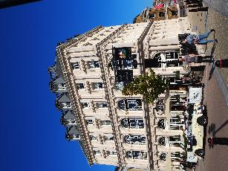

Mixed-use at the heart of Poundbury in Queen Mother Square, The Buttermarket and Pummery Square

The urban extension of Newquay at Nansledan is another example of the mixed-use model to be followed, again by The Duchy of Cornwall the development will contain 4,000 homes and an equivalent number of jobs. With the first residents moving in, in 2015, there are already around 30 businesses in place, creating the mixed-use and walk-potential as planned: <https://nansledan.com/living-working/living/local-shops/>

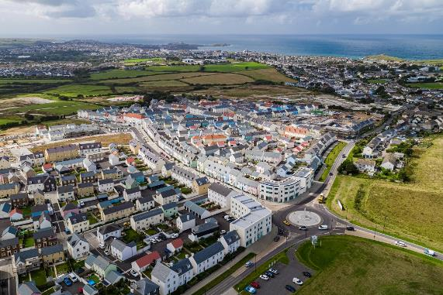 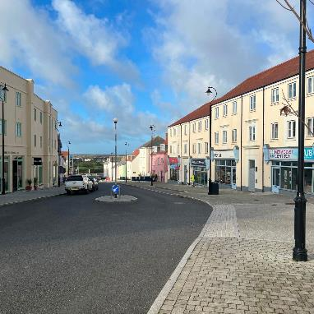

The first phase of Nansledan, with a new mixed-use high street (one of the first new ones in the UK for at least half a century) can been seen heading off from the new square in the foreground.

Workplaces at Tudeley will of course vary from those within the home or garden, through to shared office and creative spaces within centres and at mobility hubs. A café and hub will be provided from the first occupation.

Structured around a network of connected tree-lined streets and the walkable neighbourhood principles, these elements, along with the mix of uses, will encourage walking and wheeling. Filtered permeability will also ensure that active travel routes have priority, are the most direct, with the same journeys by vehicle being longer.

The Tudeley Village Travel Club will be instigated from the first occupation. This will include an exemplar car club, with mobility hubs offering e-scooter and e-bike hire. Recent research from *comouk* indicates that every car cub vehicle can replace up to 18 private vehicles.

In addition, Tudeley Village will aim to promote only 1 dedicated car space per home on plot, to help generate the modal shift to active travel and greener ways of moving. Additional car parking spaces may be available in the early years to rent, but these will be remote and a few minutes’ walk away from homes. Over time these spaces may not be needed and then the land can be re-purposed for community uses or additional dwellings. All homes will have car club membership included for the first year to help residents buy into this car-less / less-car environment.

There will be a strong desire to tackle the school run, with active travel being promoted and a comprehensive school travel plan to discourage car usage.

An all-encompassing ‘village life app’ will also be developed for Tudeley, so that you can plan your journeys easily, access on-demand bus services or hire vehicles from the mobility hubs.

**At the home, plot and block level**

The detailed design of blocks and homes will have an impact on how people choose to move. Urban blocks will contain courtyards and mews to the rear to take car parking away from the fronts of homes. When placed at the front the car becomes the ‘first choice for movement’ – see below left. Yet when placed to the side or rear, we have a much better opportunity to promote walking and cycling – see bottom right from Derwenthorpe in York, designed in conjunction with ACA.

Tick cross wrong Royalty Free Vector Image - VectorStock

Spaces such as courts and mews need to be carefully designed though so that they are places in their own rights, they should contain at least 3 homes for activity and surveillance, and be finished with high quality landscaping and materials.

All homes will have access to EV charging and communal chargers will be placed at centres and other focal points. Homes will have high-speed broadband and places to work. Our homes for the future though also need space to store mobility options, this is not a shed in the back garden but needs to be the new ‘mobility store’ at the front or side of each home, for bicycles, e-bikes, e-scooters, mobility scooters and perhaps in the future for one-person electric vehicles.

**Conclusion**

In summary, there are a range of initiatives and design moves proposed for Tudeley that will allow residents, workers and visitors to live a much more sustainable life in terms of how they move around and to have the choice for active or green modes. Internal movement comes first and the mix of uses will help facilitate this. In addition, the long-term governance and stewardship that the Hadlow Estate can offer here will ensure that these measures are a success and that movement by active travel modes thrives.

The proposition for Tudeley Village is in essence though about creating a more sustainable movement culture for the community, and allowing them to buy into something special, forward-looking whilst at the same time robust and flexible as new technologies develop and evolve.

**Andrew Cameron**

Andrew Cameron & Associates

Office for Place Board Member

Building Better Building Beautiful Commission