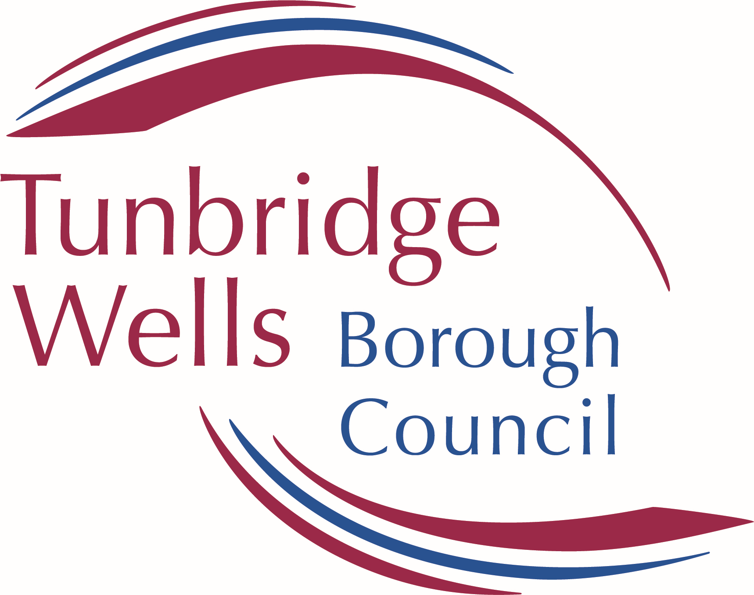 | Tunbridge Wells Draft Statement of Community Involvement  Consultation Response Form  April 2026 | Ref:  (For official use only)

We welcome your comments on the Tunbridge Wells Draft Statement of Community Involvement.

Completed forms must be received at our offices by midnight on 22 May 2026.

YOU CAN RESPOND ONLINE USING THE CONSULTATION PORTAL. Please note you do not have to sign in to respond via the portal: https://consult.tunbridgewells.gov.uk/kse/

Please refer to the ‘Making a Response’ Guidance Note which you can find attached for further information.

PART A – CONTACT DETAILS

Please note that representations must be attributable to named individuals or organisations. They may be available for public inspection and cannot be treated as confidential.
Please also note that comments received may also be available for the public to view and cannot be treated as confidential. Data will be processed and held in accordance with the Data Protection Act 2018 and the General Data Protection Regulations 2018.

 | 1. Personal Details | 2. Agent Details (if applicable)
Title
First Name
Last Name
Job title
(where relevant)
Organisation
(where relevant)
Address Line 1
Address Line 2
Address Line 3
Postcode
Telephone number
Email address (where relevant)

7. | Please tick this box if you wish to be added to the Planning Policy consultation database (so you can be kept informed of any future Planning Policy consultations)

PART B – YOUR REPRESENTATION

Comments can be made on any part of the Statement of Community Involvement document. Please add the paragraph numbers that you wish to comment on for each section of the document and then write your comments on that part of the document.

Section 1: Introduction
Paragraph | Comments

Section 2: The Planning Policy context for Tunbridge Wells
Paragraph | Comments

Section 3: Involvement in Planning Policy
Paragraph | Comments

Section 4: Consultations on planning applications and notifications
Paragraph | Comments

Alternatively, you may email or scan forms to: planning.policy@tunbridgewells.gov.uk or print them off and send them by post to: Tunbridge Wells Borough Council, PLANNING POLICY, Town Hall, Royal Tunbridge Wells, TN1 1RS

Signature |  | Date

Thank you for taking the time to complete this form.

Closing date for responses: midnight on 22 May 2026

